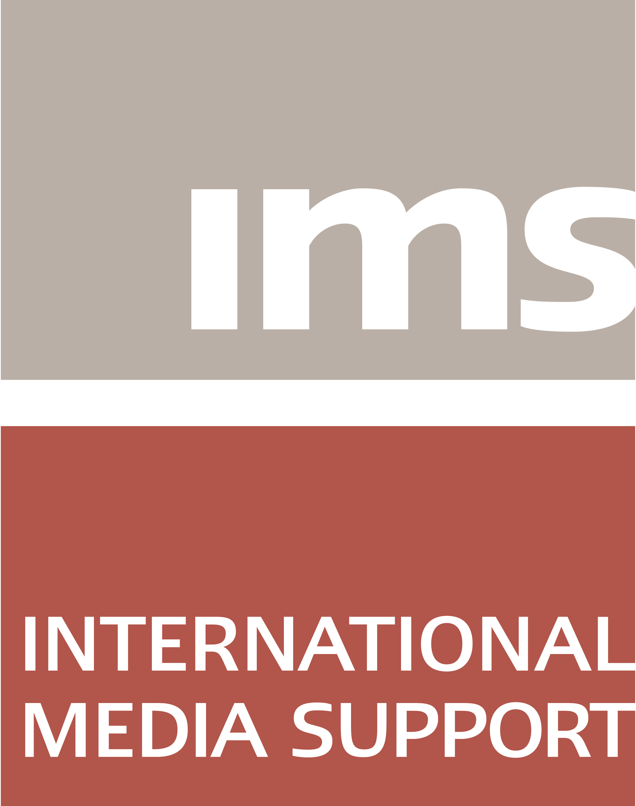

Assistant Programme Manager

International Media Support (IMS) is seeking an Assistant Programme Manager for our Middle East and North Africa (MENA) Department, with a focus on North Africa.
International Media Support (IMS) is a non-profit organisation working to support media in countries affected by armed conflict, human insecurity and political transition. Across four continents, IMS helps to strengthen professional journalism and ensure that media can operate in challenging circumstances.
In the MENA region, we work with partners in Tunisia, Marocco,, Libya, Yemen, Syria, Jordan, Iraq, and elsewhere to further the safety of journalists and promote media reform, build institutions and develop media content

Job summary
The task of the Assistant Programme Manager is to assist Programme Managers in all steps of Programme Cycle Management and in organising training, workshops and other activities in North Africa. Furthermore, the Assistant Programme Manager will coordinate partner relations and contact (projects, contracts, preparation of payments and finalisation of accounts) and organise travel and logistics related to programme activities.
The Assistant Programme Manager will occasionally travel to programme countries to support local partners in administrative issues/undertake financial capacity building/training.
The Assistant Programme Manager will refer to the Head of the MENA Department.
Responsibilities
- Prepare and follow up on financial and administrative issues related to the handling of partner contracts, including preparation of budgets, transfer of funds, controlling of accounts and audits;
- Elaborate and follow up on project contracts in English;
- Compile financial and narrative reports for donors;
- Assist on elaboration and budgeting of programme proposals;
- Coordinate events and travel logistics;
- Travel occasionally to programme countries to assist partners in their financial and administrative setup and compliance checks.
Qualifications
- Relevant educational background in e.g. accounting, finance or administration and/or at least 3 years of relevant experience;
- Knowledge and experience of administration and financial control procedures in relation to project administration;
- Excellent command of Excel;
- Experience with Microsoft Dynamics NAV will be considered an asset;
- Fluency in written and spoken English and French at a business level is a prerequisite;
- Fluency in written and spoken Arabic is an advantage;
- Experience working with international donors compiling financial and narrative reports and adhering to donor guidelines will be considered an asset.

Personal skills
- Strong team working skills and the ability to handle many tasks at once while working independently;
- Strong interdisciplinary and intercultural team-working skill;
- Ability to work under pressure and to meet targets and deadlines;
- Ability to react quickly to changing priorities;
- Strong attention to order and detail.

IMS provides a fast-paced work environment with colleagues and partners in and from many corners of the world. Our working language is English. As Assistant Programme Manager in the MENA department you will be part of a team of about 20 committed colleagues.
Everyone with the required qualifications and skills is encouraged to apply, regardless of sex, sexual orientation or gender identity.
Duration and location

The period of the position is limited to 1 year. The APM position is 30 h/week. Compensation commensurate with experience and IMS policies. Duty station: IMS headquarters, Copenhagen, Denmark. Starting date: As soon as possible.
How to apply

Please submit a brief written application and curriculum vitae in English to jobs@mediasupport.org no later than 23 January 2017. Kindly mark the application “APM MENA” in the subject header. Please note that only short-listed candidates will be contacted for a follow-up interview. Interviews with selected candidates will take place during the last week of January 2017.
For further information about IMS please visit www.mediasupport.org or contact Head of the MENA Department, Michael Irving Jensen at mij@mediasupport.org.

