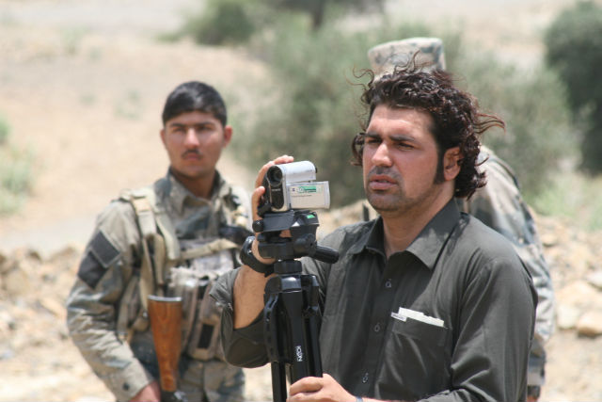

JOURNALIST SAFETY

mediasupport.org

DOCUMENTING BEST PRACTICES ON THE SAFETY OF JOURNALISTS

PROJECT OVERVIEW

* More than 90 per cent of journalists killed are local journalists. The safety of journalists is vital to ensuring that the media can fulfil its role as society’s watchdog.
* This project builds on IMS’ long-lasting efforts to bolster and promote locally led, national mechanisms that seek to secure the safety of journalists such as those in Afghanistan, Pakistan and Nepal.
* This project will also draw on the International Federation of Journalist’s global network of journalist unions working for journalists’ safety.
* The UN Plan of Action on the Safety of Journalists and the Issue of Impunity led by UNESCO provides a platform on which actors in the field of media can improve coordination on the safety of journalists.
* From June 2016 to end 2017, IMS and the International Federation of Journalists (IFJ) will lead efforts to document best practice models of locally-led safety mechanisms for journalists in Colombia, Philippines, Pakistan, Indonesia, Iraq, Afghanistan and Nepal.
* The findings will be compiled into a global research study that aims to inform local media practitioners, authorities and media development organisations working to improve the safety of journalists in the seven selected countries and beyond.
* Roundtables will gather key media stakeholders in each country between June and December 2016 to analyse and validate the findings while the study is under way.
* The research study will be launched at an international symposium in 2017 with senior civil society representatives and policy makers from the selected countries.
* The International Federation of Journalists will conduct national programmes to promote the findings of the study and strengthen existing and new safety networks in target countries.
* Peer-to-peer partnerships and exchange visits will be organised between practitioners and policy makers in the selected countries to optimise learning about safety models.

The project aims to connect the global efforts and emerging best practices in the area of the safety of journalists by:

* Sharing best practices and building the capacity of local safety mechanisms through peer-to-peer partnerships;
* Documenting the best practices that exist within civil society and government-led safety mechanisms for journalists through a broad global research project targeting Colombia, Philippines, Pakistan, Indonesia, Iraq, Afghanistan and Nepal;
* Creating local and global networks in the seven selected countries focusing on the safety of journalists.

Journalist covering conflict in Afghanistan. Photo: Farook Jan Mangal